#### **AVL Remove**

* + 2 children: swap with IOP then remove
  + 1 child: swap with child then remove
  + No child: remove
  + We remove the same way we would remove a node in a BST.

#### **Eg: remove (10)**

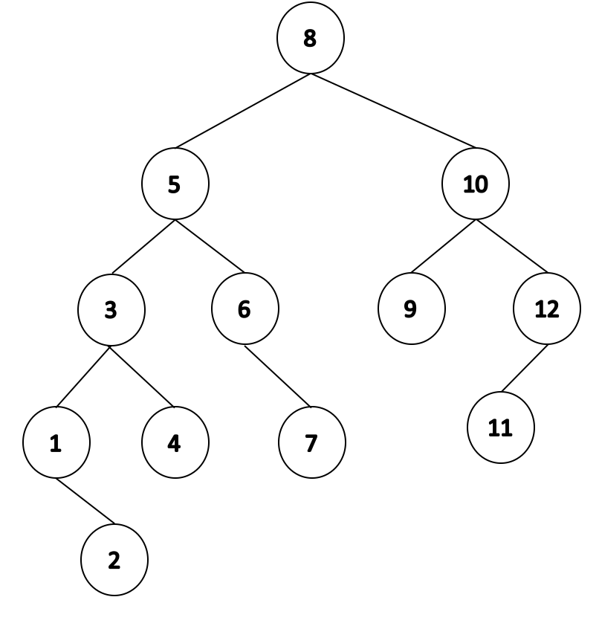 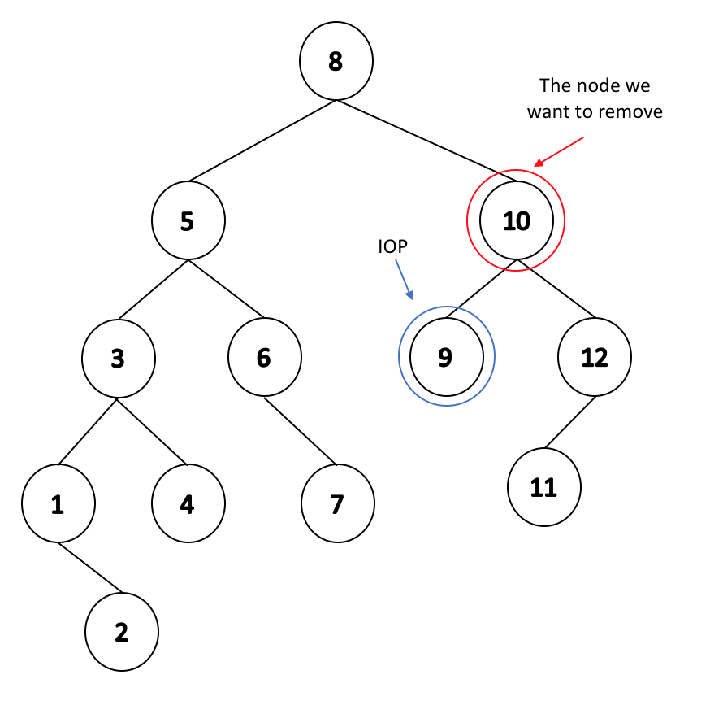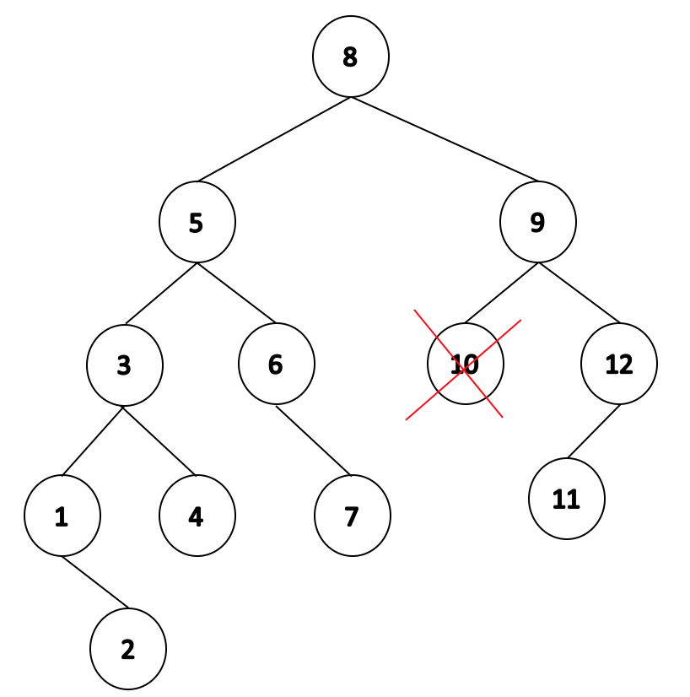

* After we removed the node, we can see that we are left with an elbow with the lowest point of imbalance at 9. We know how to fix a case where b(9) = 2 and b(12) = -1 (RL rotation).

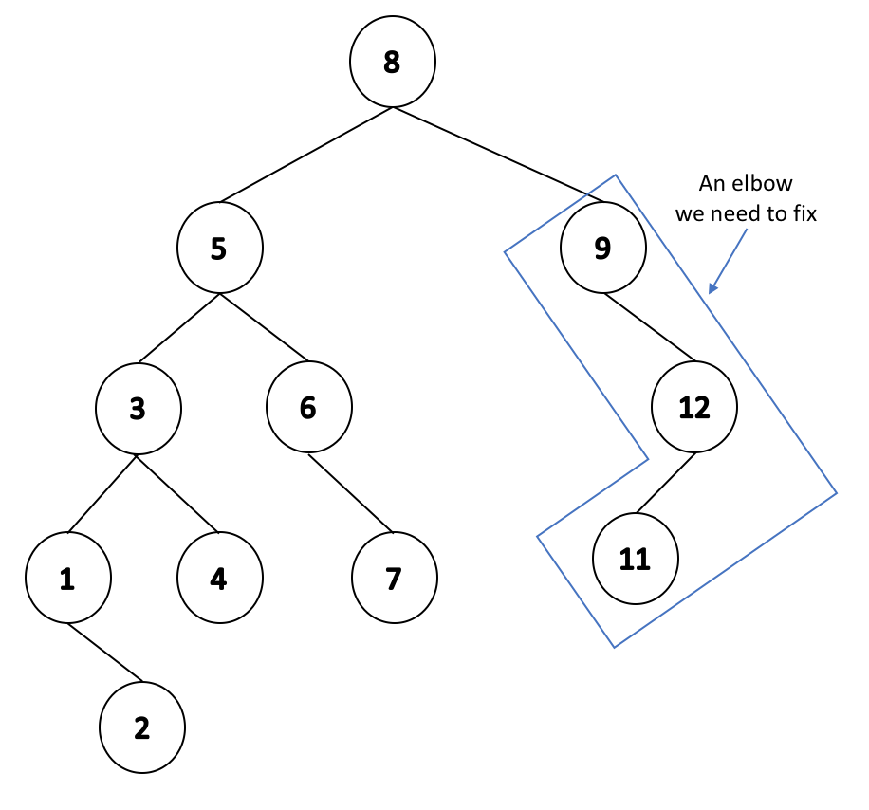 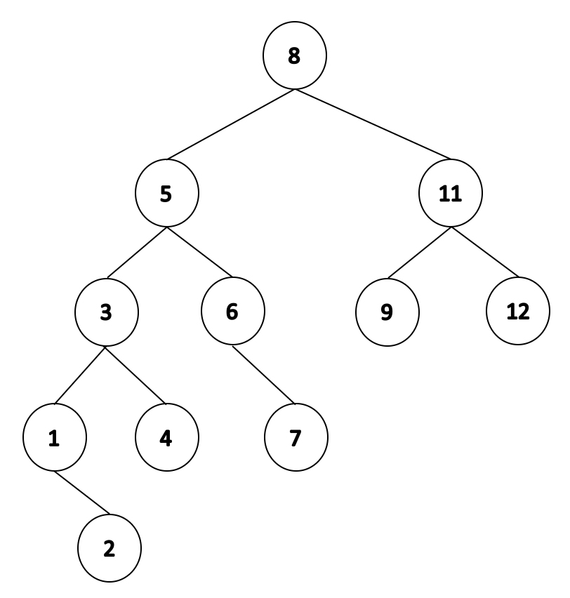

* We have corrected the imbalance at 9, but is the tree as a whole balanced?
  + If we check b(8), we will see that it is two. We corrected one imbalance, but we have created another one. Again we know how to fix this: b(8) = -2 and b(5) = -1 (rotate to the right)

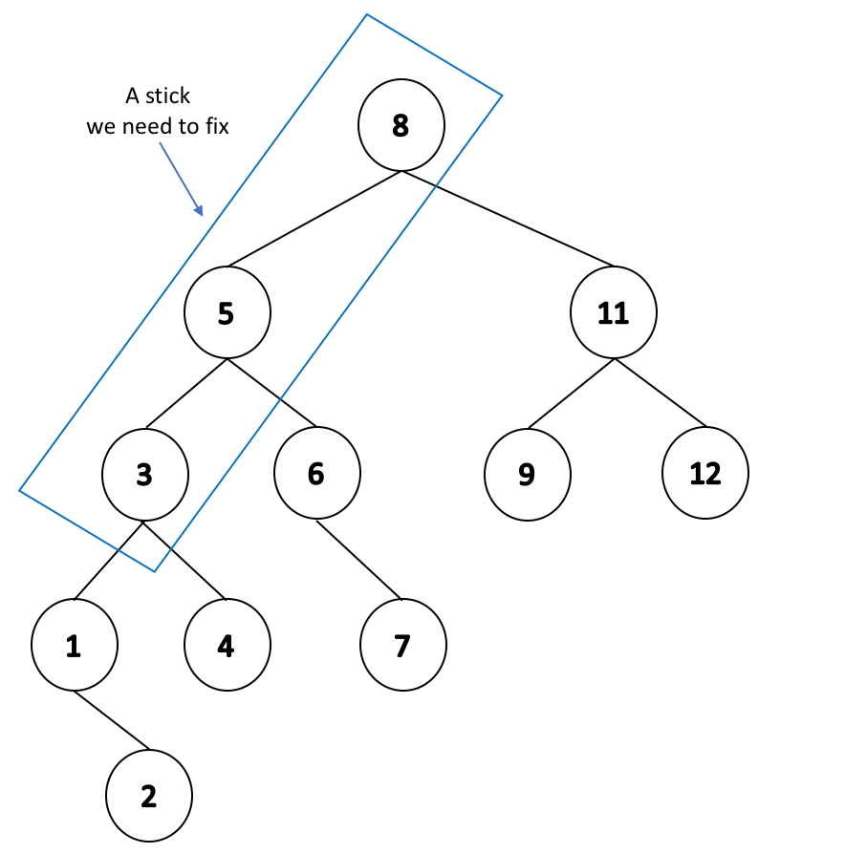 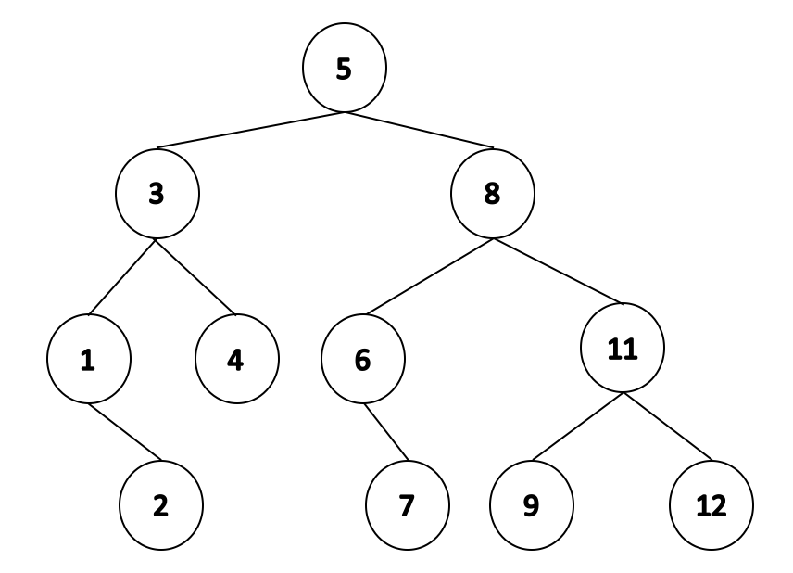

#### 

#### **AVL summary**

#### **Big-O definition**

If we say a function is a Big O of another ie f(n) = O(g(n)) if and only if there exists some constants variable c,k such that f(n) ≤ c * g(n) and for all n > k.

* In other words, c*g(n) is the upper bound of the f(n) and f(n) is always below the upper bound
* For all trees that are at least k nodes big, we know that the height h of that tree will be less than c * g(h). The definition implies that small values of k don’t matter.

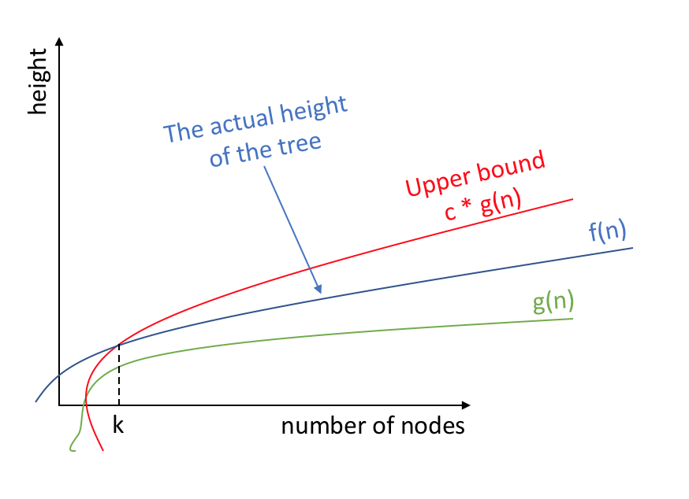

However the definition above is hard to prove the maximal value of the height and we should invert the definition above.

The inverted definition of above definition:

* + For all integer n and some int k such that n > k, we have n > c * g-1(h).
  + In other words, give the tree of height h, what is the minimal number of nodes of that tree .
  + There is a unique representation of a tree with minimum number of nodes.

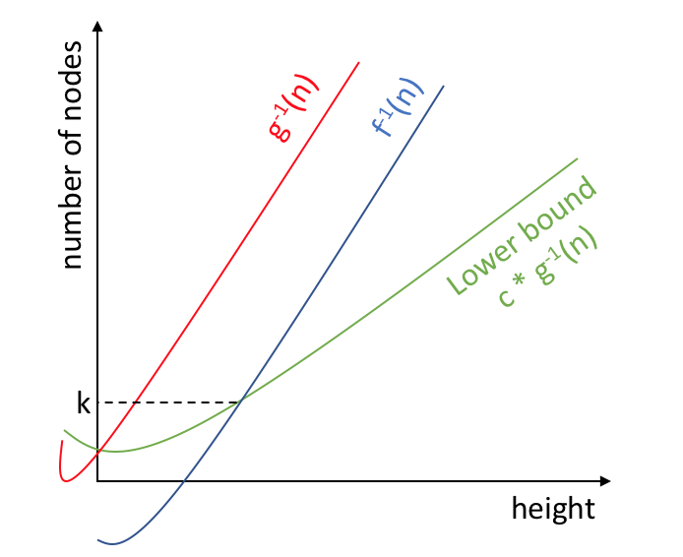

* The representation of the function that has the smallest number of nodes in an AVL tree of height h → N(h):

N(h = -1) = 0 N(h = 0) = 1 N(h = 1) = 2

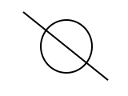 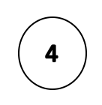 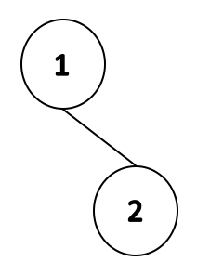

N(h = 2) = 4 N(h = 3) = 7

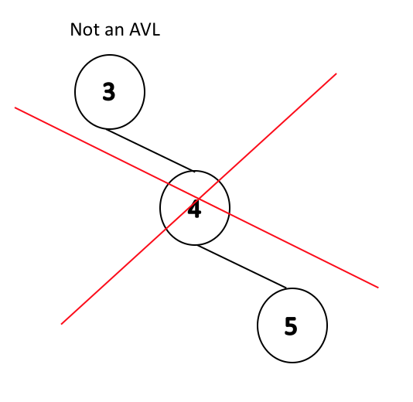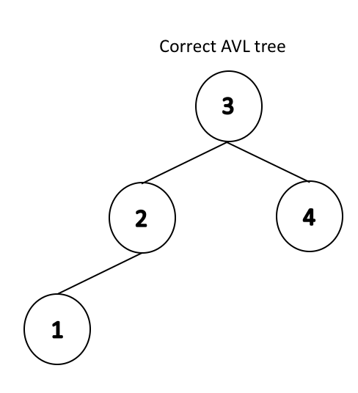 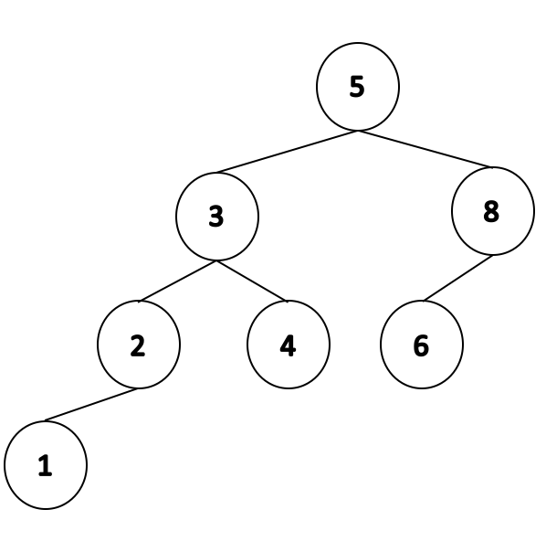

A minimal AVL tree is going to have a balance of -1(1).

* + Looking at these couple of cases, we can notice a recursive relation:
    - **N(h) = 1 + N(h - 1) + N(h - 2)**  
       left-side right-side
  + Simplify the above function
    - N(h) > N(h - 1) + N(h - 2) → we can drop a constant, but now N(h) is greater and not equal anymore.
    - We know that N(h - 1) > N(h - 2) → because AVL min tree has balance of -1, we know that left side is longer than the right side.
    - N(h) > 2 * N(h - 2) → we can’t drop N(h - 1), but above we concluded it is larger than N(h - 2), this new form is correct.
    - The last step would be to find closed form which is 2h/2 and the following are the steps to get the closed form:

#### **Theorem: An AVL tree of height h has at least 2h/2 nodes for h > 0 → N(h) > 2h/2.**

**Proof:**

* + Consider an AVL tree and let h denote it’s height
  + Base case: h = 1 and h = 2

AVL Thm AVL Thm

h = 1 21/2 = √2 ≅ 1.4 h = 2 22/2 = 2

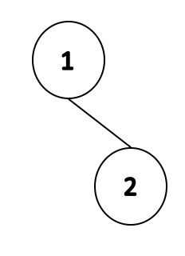 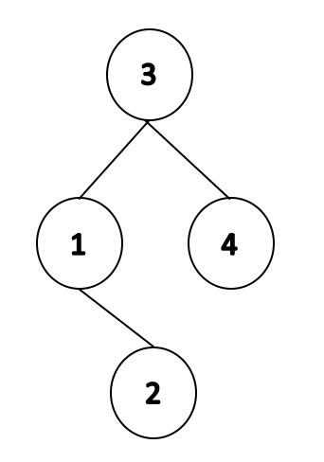

An AVL tree of height 1 An AVL tree of height 2

has at least 2 nodes has at least 4 nodes

Inductive hypothesis: for h > 2, ∀ j < h, N(j) > 2j/2 .

We want to show: N(h) = 1 + N(h - 1) + N(h - 2)  
 > 2 * N(h - 2)  
 > 2 * 2(h-2)/2  
 > 2h/2

Therefore an AVL tree of height h has at least 2h/2 nodes.

We have proved that n ≥ N(h) > 2h/2 → n > 2h/2

Now we invert back: h < 2log(n) QED

**Note: This theorem will give a very loose bound as a result of our lower bounding of the formula. But if we want to calculate N(h), we need to calculate using the recursive formula:**

**N(h) = 1 + N(h - 1) + N(h - 2),**

**which is a more precise bound***.*